
Artificial Intelligence Lab_CS-202L
UW-24-CS-BS-101
Registration NO:
Muhammad Talha_CS.3ndB
Lab Task # 05
UNIVERSITY OF WAH(UOW)

DEPARTMENT OF COMPUTER
SCIENCE

COURSE:

SUBMITTED TO:

Mr. Hasssan Shafaqat
SUBMITTED BY:

Applying different functions from numpy:
Task # 01
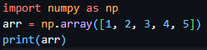
Task # 02
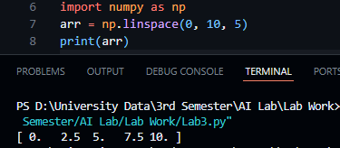
Task # 03
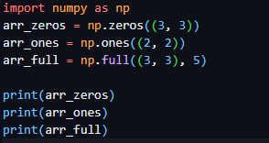
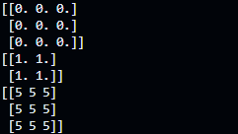
Task # 04
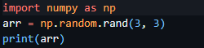
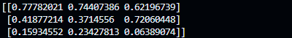

Task # 05
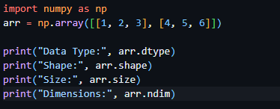
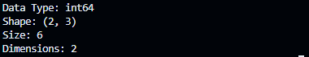
Task # 06
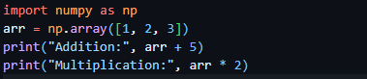
Applying Pandas function Code:
Task # 07
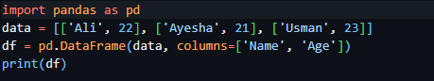
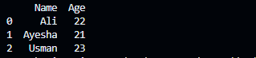

Task # 08
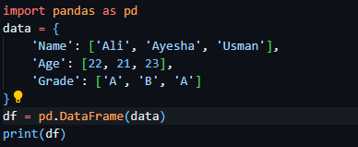
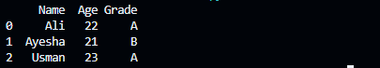
Task # 09
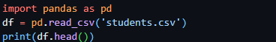
All these tasks I practice are by using different functions inside pandas and numpy library

